**MODSAFE ROADS...!**

🡪ABSTRACT

There are many real life problems which require a solution so that society could get benefit and our solution entirely focuses on the same part. In this section I would like to give a glimpse of our idea and its application in real life based scenario. First is energy conservation, in this era where population is increasing and resources are decreasing we have implemented energy generation using speed breakers and an innovative idea to be present at the toll as well as to decrease the accidents on the U shaped curves all solved with innovative techniques.

🡪A SMALL BRIEF(Introduction)

Beginning with the idea phase, we have implemented a unique pattern of speed breakers which would just not limit the speed of vehicles but also utilize and process the energy generated by their passage which in turn would power the lights as well as the toll plaza nearby. Now the next part comes over the toll where an automatized solution will reduce man power by many folds and reduce the time spent on the toll plaza, also we have inculcated the prepaid toll system which will be beneficial to passengers. Third phase starts with the mountain area U curved roads in which we will be easing and reducing the risk of accident chances on the road also we have inculcated a system in which we will be sending accident alert to nearby hospital as well as toll plaza.

🡪RESEARCH PAPERS REFERNECE

Great ideas come with great research, some of the paper which really helped us are as follows: -

1. International Journal of Innovative Research in Electrical, Electronics, Instrumentation and Control Engineering ISO 3297:2007 Certified Vol. 5, Issue 5, May 2017 (<https://www.ijireeice.com/upload/2017/may-17/IJIREEICE%2049.pdf>)
2. International Journal of Computer Engineering & Technology (IJCET) Volume 9, Issue 3, May-June 2018, pp. 132–139, Article IJCET_09_03_015 (<http://www.iaeme.com/ijcet/issues.asp?JType=IJCET&VType=9&IType=3.pdf>)
3. International Journal for Research in Applied Science & Engineering Technology (IJRASET) ISSN: 2321-9653; IC Value: 45.98; SJ Impact Factor: 6.887 Volume 6 Issue II, February 2018(<https://www.ijraset.com/fileserve.php?FID=13623>)

🡪IDEA DESCRIPTION

* **PHASE -1 (ENERGY)**

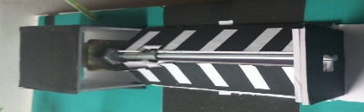In this Era the need of the hour is to conserve and use energy resources very judiciously and considering the same we have designed an automated solution for speed breaker electricity generation which in turn would power the lights as well as the toll plaza nearby. For a prototype basis we have just generated electricity in this phase of our project and this very own kind of speed breaker can be very beneficial in near future.

* **PHASE -2 (TIME)**

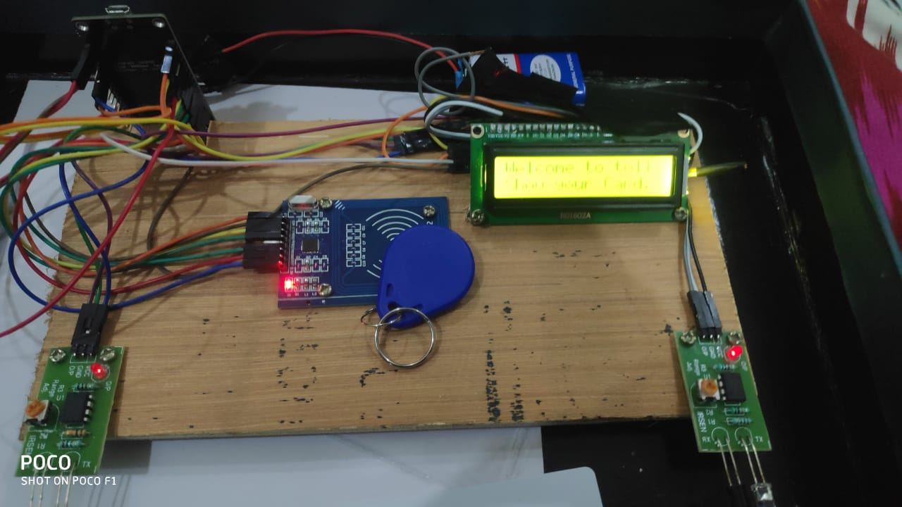Living in a generation where time is money and security a concern which required a modern solution for the same, which was created by designing an extra ordinary toll plaza where your key chain would just open the toll gate. Surprised, but yes it is possible and what if you pay the toll before you just even depart from home, and toll without man labour and an automatized toll gate would save your time and will give you a smooth journey experience.

* **PHASE -3 (SAFETY)**

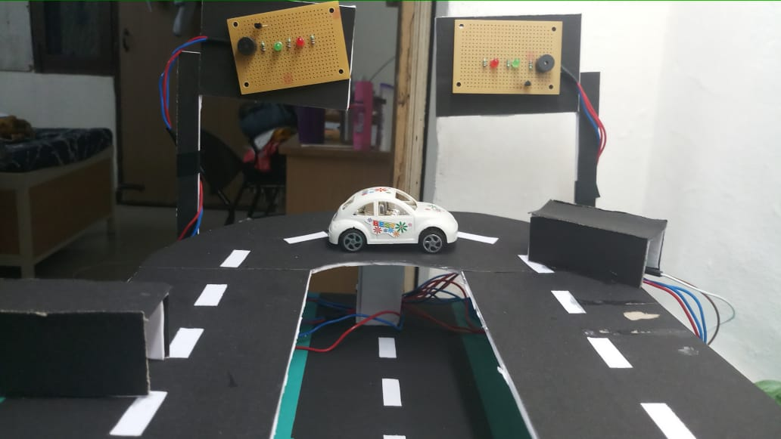According to a report everyday 2500 people die out of accidents and as we all know maximum of accidents happen on mountainous curves which just blind the driver about the vehicle coming in front, specially this scenario is most prevalent on U-curved roads and for creating a real life application, Arduino boards can’t be used so designing a network using a circuit would lead to prevention of accidents as it will sound the buzzer whenever a vehicle is coming and alert the follow driver about the same.

🡪COMPONENTS REQUIERED

* Node MCU Development Board
* 1000 rpm gear motor
* IR Modules -4
* 2N222A transistor -2
* Buzzer -3
* 7805 Regulator
* 220-ohm resistor -8
* Led (R-G-B) (4-4-10)
* Zero PCB Board
* Belt wire
* RFID sensor
* LCD display 16*2
* I2C chip
* Motor clamp
* Motor shaft
* Servo motor
* Bread Board
* Wooden Block
* Jumper Wire
* Flexible wire
* Switch
* 9 Volt battery
* Other stationary material

🡪WORKING

In the construction of speed breaker, we used 1000 rpm gear motor and fitted it in a way such way with a circuit that it rotation in clockwise direction would power the lights on the left side of the road and the rotation in anti-clockwise would generate electric power too. This energy can be harnessed to power toll, nearby lights and can even be stored by using motor generator principle.

In the second phase we configure the node MCU with RFID sensor, I2C, LCD Display, Servo motor, IR sensor. Whenever a vehicle passes in front of the first IR sensor it will prompt to show card which is your car keychain and the balance will prompt on the screen and will be stored back there in the database and soon as the card is validated the toll gate will open and as soon as it passes from second IR sensor it will close the gate and wait for the next vehicle reducing manpower by many folds.

When it comes to safety then we just can’t compromise and this is what we have taken care of, we know maximum of accidents happen on mountainous curves which just blind the driver about the vehicle coming in front, specially this scenario is most prevalent on U curved roads and for creating a real life application, Arduino boards can’t be used so designing a network using a circuit would lead to prevention of accidents as it will sound the buzzer whenever a vehicle is coming and alert the follow driver about the same.

🡪Circuit Diagram

Circuit Diagram of Traffic lights have been displayed below: -

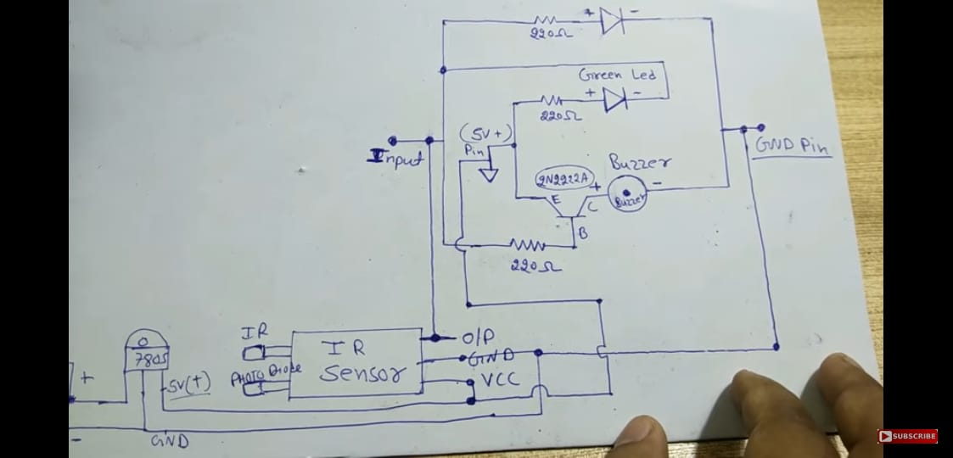

🡪PROGRAM FOR THE PROJECT

#define SS_PIN D4

#define RST_PIN D3

#define IR_PIN D0

#define IR2_PIN D2

#include <SPI.h>

#include <MFRC522.h>

#include <LiquidCrystal_I2C.h>

#include <Servo.h>

Servo servo;

int lcdColumns = 16;

int lcdRows = 2;

int val=0;

int val2=0;

int cardbalance = 500;

int a=0;

LiquidCrystal_I2C lcd(0x27, lcdColumns, lcdRows);

MFRC522 mfrc522(SS_PIN, RST_PIN); // Create MFRC522 instance.

int statuss = 0;

int out = 0;

void setup()

{

Serial.begin(9600); // Initiate a serial communication

SPI.begin(); // Initiate SPI bus

mfrc522.PCD_Init(); // Initiate MFRC522

pinMode(IR_PIN, INPUT);

lcd.init();

lcd.backlight();

lcd.setCursor(0, 0);

lcd.print("IOT TOLL PLAZA !");

lcd.setCursor(0,1);

lcd.print("EVERYTHING IS OK");

servo.attach(15); //D8

servo.write(0);

delay(2000);

}

void loop()

{

val = digitalRead(IR_PIN);

val2 = digitalRead(IR2_PIN);

Serial.println("***");

Serial.println(val2);

Serial.println("***");

delay(1000);

if(val==HIGH)

{

lcd.clear();

lcd.setCursor(0, 0);

lcd.print("Welcome to toll.");

lcd.setCursor(0, 1);

lcd.print("Show your Card.");

a=1;

delay(1000);

}

else

{

}

// Look for new cards

if ( ! mfrc522.PICC_IsNewCardPresent())

{

return;

}

// Select one of the cards

if ( ! mfrc522.PICC_ReadCardSerial())

{

return;

}

//Show UID on serial monitor

Serial.println();

Serial.print(" UID tag :");

String content= "";

byte letter;

for (byte i = 0; i < mfrc522.uid.size; i++)

{

Serial.print(mfrc522.uid.uidByte[i] < 0x10 ? " 0" : " ");0

Serial.print(mfrc522.uid.uidByte[i], HEX);

content.concat(String(mfrc522.uid.uidByte[i] < 0x10 ? " 0" : " "));

content.concat(String(mfrc522.uid.uidByte[i], HEX));

}

content.toUpperCase();

Serial.println();

if (content.substring(1) == "FA E9 D4 83") //change UID of the card that you want to give access

{

if(cardbalance>0 && a==1){

a=2;

lcd.clear();

cardbalance=cardbalance-50;

lcd.setCursor(0, 0);

lcd.print("BALANCE ");

lcd.setCursor(8,0);

lcd.print(cardbalance);

//delay(1000);

// clears the display to print new message

//lcd.clear();

// set cursor to first column, second row

lcd.setCursor(0,1);

lcd.print(" SAFE JOURNEY ");

delay(1000);

//lcd.clear();

statuss = 1;

servo.write(180);

delay(5000);

servo.write(0);

delay(1000);

}

else if(cardbalance<=0&&a==1)

{

lcd.clear();

lcd.setCursor(0,0);

lcd.print("ALERT! BALANCE:0");

lcd.setCursor(0,1);

lcd.print("Please Recharge");

}

}

else {

//Serial.println(" Access Denied ");

lcd.clear();

lcd.setCursor(0, 0);

// print message

lcd.print("NOT A VALID CARD");

lcd.setCursor(0,1);

lcd.print("SECUIRITY ALERT");

delay(3000);

lcd.clear();

statuss = 1;

//delay(3000);

lcd.setCursor(0, 0);

// print message

lcd.print("IOT TOLL PLAZA");

//delay(500);

lcd.setCursor(0,1);

lcd.print("Show your card");

}

}

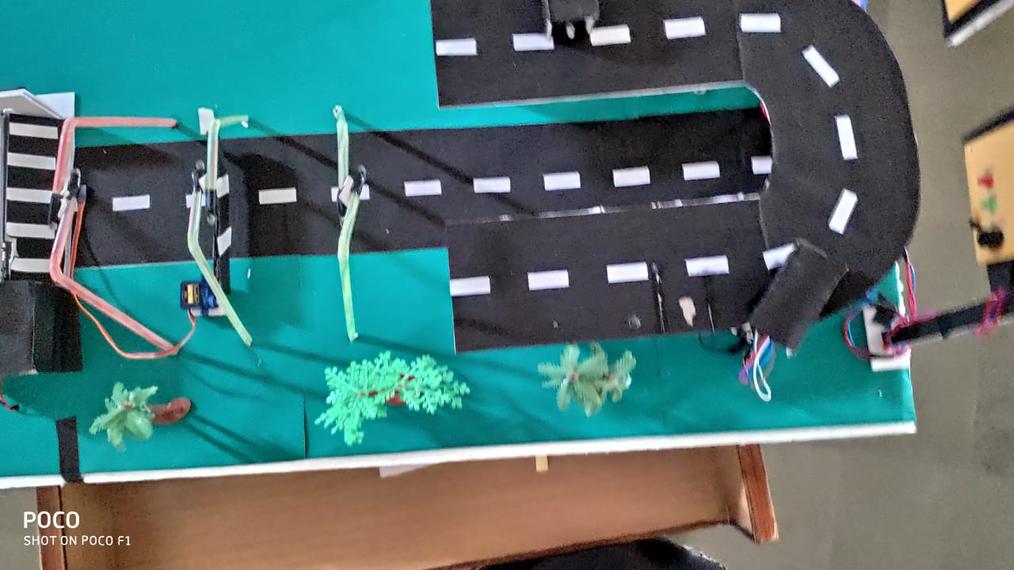🡪SOME PICTURES



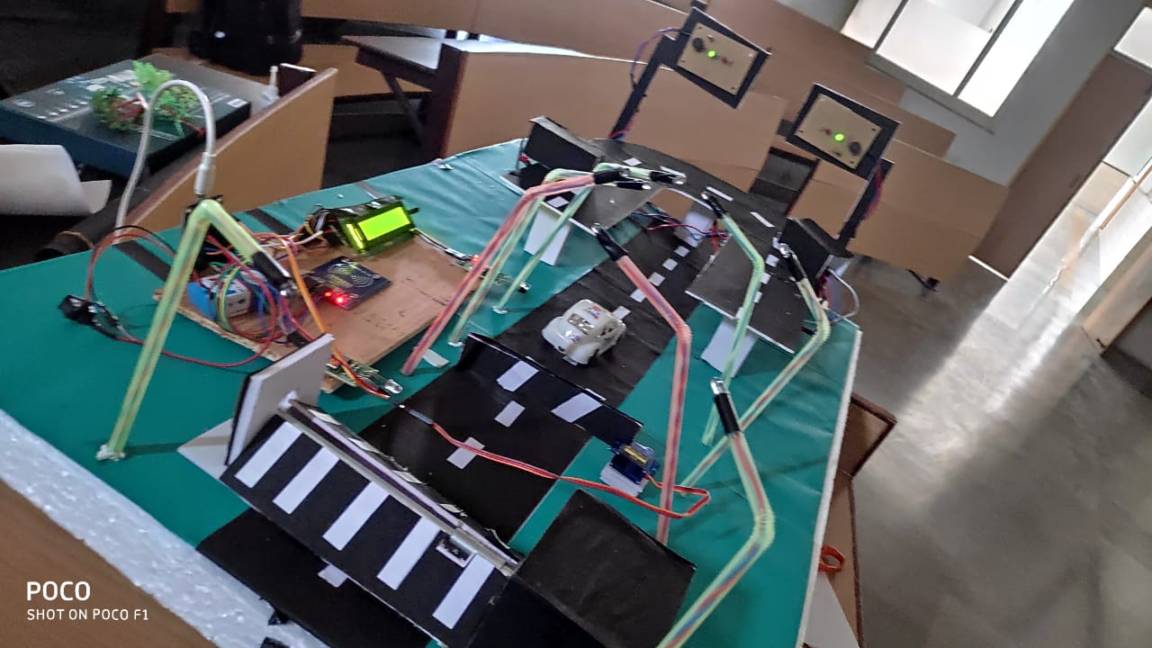

🡪CONCLUSION

This Idea is named as MODSAFE Roads as it is a perfect blend of Modern and Safe roads and it solves the existing problem of our 3 major concerns. This system will change the entire scenario of present roads and will take it to next level and will help in development of the country as well as the society.

* Future Plans

In future the alert of any mishap in the way could be sent to the nearby medical institute as well as the nearby police and toll plaza so that they can take suitable actions for the same and by this way mishaps can be prevented and for the toll plaza we will be creating a secure payment gateway so that no theft or online fraud can happen.

We will keep including the new scope and new ideas in our project and will not just limit it to academic scope.

-o-